
Sustainability of Metaverse (Sustainverse)
Barina EVİREN, Denizcan BOZKURT
Assoc. Prof. Ceylan YOZGATLIGİL
December 22, 2022- METU Culture and Convention Center

ABSTRACT
The purpose of this project is to explain sustainability of metaverse. With the advancement of technology, the task of data centers, which deploy thousands of computations, storage, and communication devices leading to high energy utilization and carbon emissions, has started to increase. There is a large amount of data in the metaverse. Therefore, it requires high-speed and efficient computation. Developing this universe can be significantly simplified through data centers and cloud systems. In this project, the question of how much energy consumption could increase with this development was investigated. TRUBA datasets are used to research the energy consumption of data centers. Although the trend of the data has gone down, we cannot say that the energy consumption has decreased because we can easily say that TRUBA is not popular when compared to its alternatives as AWS. As a result of this project, global energy consumption is thought to increase, even if the energy consumption of some metaverse systems decreases.
EXPERIMENTAL PROCEDURE
There are not many studies in the literature about the effect of metaverse on earth’ climate system. Metaverse is a new web-based application that combines several new technologies. Metaverse includes leading-edge technology such as cloud technology, artificial intelligence, and blockchain to make a difference in art, social platforms, gaming, or business (Ning et al., 2021). This kind of technology requires capable computing and storage; for this reason, data centers and cloud systems form the infrastructure of the Metaverse. Since the Metaverse is a relatively new concept and not common, there was no energy consumption data about it. However, cloud computing and data centers are the two main tools of the Metaverse. For this reason, the daily electricity consumption dataset from TRUBA, Türkiye's national data center for high-performance and grid computing, is used to explain the energy usage of high-performance computing jobs submitted from all research institutions and researchers in Türkiye.
Data centers are large groups of connected computing servers frequently used to store, process, or transmit large quantities of data. The cost of powering a typical data center doubles every five years; this means that data centers use a large amount of electricity, which has led to several environmental issues (Liu et al., 2020). Therefore, the amount of energy consumed by data centers will be examined over the years using TRUBA data. The dataset includes the daily energy consumption of supercomputers, storage, and networking devices. Data pre-processing and feature engineering were implemented on the series. For instance, thanks to new technology that lets big companies use energy more efficiently, the PUE value was considered 1.1 instead of the average original value of 1.5. In addition, the energy consumption of TRUBA was converted to kilowatts to simplify. Data was missing during the covid-19 period. Therefore, there were two periods, before covid-19 and after covid -19. Both period trends were down. In the final model, two periods were combined assuming that before and after the pandemic, the trend in the series is similar. For forecasting, Prophet model was used in Python 3.2 under fbprophet library. The seasonality was removed to get more precise results. The strength of the sparse prior is increased to make the trend more flexible. In Figure 1, the prediction and forecast performance of the model can be seen. Here, dots represent change points, and the line represents the trend. At the end of the analysis, the model got a 0.022 MAPE score. That means it is good and accurate forecasting. The result is seen in Figure 1. The overall trend is going down. That can be explained by TRUBA technology's improvement and popularity of TRUBA among
alternatives. According seen in Figure 1. The overall trend is going down. That can be explained by TRUBA technology's improvement and popularity of TRUBA among alternatives. According to the TRUBA website, TRUBA adds new sources, and alternatives. According to the TRUBA website, TRUBA adds new sources, and TRUBA is far behind in popularity compared to its alternatives seen in Figure 2. While TRUBA fluctuated between 0 and 10.
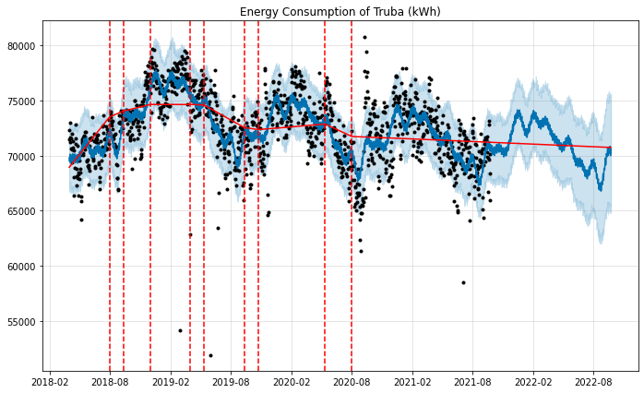
Figure1: Forecasting of TRUBA Energy Consumption
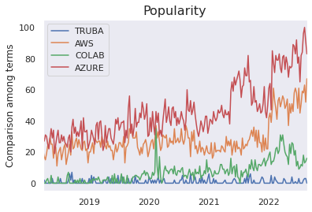
Figure2: Google Trends of TRUBA, AWS, COLAB and AZURE in Turkey
MOTIVATION
The issue of sustainability becomes one of the biggest questions when climate change and Metaverse come together. The decrease in non-renewable energy resources, the difficulty of integrating renewable energy resources into consumption, developing technology give rise to thought about future of world. Because of the quick growing of technology such as cloud systems and big data, data communication and computing have caused a significant amount of energy consumption in data centers. (Tian et al., 2020) Koomey was the first to study the data center electricity usage, and it has been stated that data centers used 1.5% of global electricity in 2010. Because of the quick growing of technology such as cloud systems and big data has caused a significant amount of energy consumption in data centers. Koomey was the first to study data center electricity usage, and it has been stated that data centers used 1.5% of global electricity in 2010. For good measure, Andrae and Edler (2015) says that data centers will require 3-13% of global electricity in 2030, up from 1% in 2010. In Figure 3, they showed electricity usages for data centers. When examining the best-case scenario, there has been huge

elevation in the use of data centers in 20 years. The motivation of this project is to investigate how data centers and cloud system increase energy consumption and carbon emission and show how to make it more sustainable.
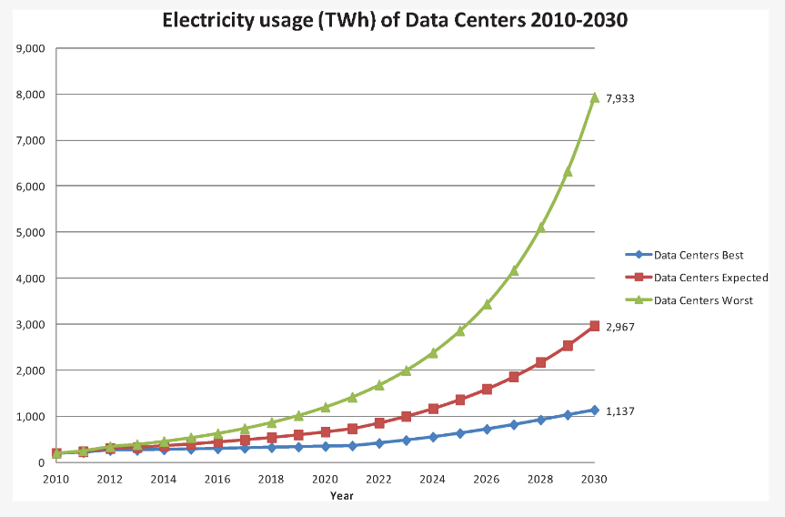
Figure3: Electricity usage of Data Centers in 2010 to 2030
CONCLUSION
In this project, the sustainability of the Metaverse was examined by modeling the total daily energy consumption of supercomputers, storage, and networking devices. Sustainability is an important concept to continue to exist in this world without exploiting the world we live sources. Due to new technologies, people tend to live in a digital world more, and the Metaverse will join our lives soon. This project is based on the hypothesis that the Metaverse will require high energy in the future. However, from TRUBA data, results demonstrate that there will be less energy consumption in the future. Unlike TRUBA, other global alternatives such as AWS or Colab are becoming more popular. If the energy demands of these enormous global alternatives keep increasing, the Metaverse will not be sustainable.
Companies should use more green energy, and centralized data centers should be preferred. The establishment of data centers in the Pan-Arctic region in the future can effectively relieve climate change and energy problems. The global data center’s energy consumption and carbon emissions are being reduced by about 301 billion kWh and 720 million tons of CO2 in the centralized scenario compared to the decentralized scenario in 2030 (Liu et al., 2020). In addition, this project is not over, and the Metaverse's sustainability and energy consumption of its tools keep being researched.
RESULTS AND DISCUSSIONS
The forecast results show that TRUBA’s, energy consumption will be decreased in the future. On the other side, other research found that would be vice versa. According to Cisco (2016), global data center’s traffic growth is predicted. Their results present that data center’s usage is already increasing, and the Metaverse will increase the rate of ascension. A lack of data may cause this contradictory results. In addition, this study only shows that the energy consumption of TRUBA is decreasing, but it must be noticed that the usage of cloud servers used for deep-learning tasks are increasing. This means that researchers in Türkiye tent to move their computational tasks to the cloud services. With the other tools' consumption data and other parameters provided, better models can be established, and better results that show the true nature of the metaverse related CO2 emissions may be obtained.
REFERENCES
Ning, H., Wang, H., Lin, Y., Wang, W., Dhelim, S., Farha, F., Ding, J., & Daneshmand, M. (2021). A Survey on Metaverse: the State-of-the-art, Technologies, Applications, and Challenges. Computers and Society. https://doi.org/arXiv:2111.09673v1
Liu, Y. L., Wei, X., Xiao, J., Liu, Z., Xu, Y., & Tian, Y. (2020). Energy consumption and emission mitigation prediction based on data center traffic and PUE for global data centers. Global Energy Interconnection. https://doi.org/10.1016/j.gloei.2020.07.008
Andrae, A. S. G., & Edler, T. (2015). On Global Electricity Usage of Communication Technology: Trends to 2030. MDPI. https://doi.org/10.3390/challe6010117
Koomey, J. Worldwide electricity used in data centers. Environ. Res. Lett. 2008, 3, 1–8. https://doi.org/10.1088/1748-9326/3/3/034008
Prophet. facebook.github.io
https://facebook.github.io/prophet/docs/quick_start.html#python-api

